**CHOCOLATE QUALITY AUDITING**

INTRODUCTION

Chocolate is one candy that has been said to induce happiness and joy in those who enjoy it. The world enjoys chocolate for its health benefits and sweet taste. Chocolate's history dates back to the year 400 AD (Tan et al., 2021). Cacao beans are processed into chocolate using a number of steps, including fermentation, drying, roasting, nib grinding and refining, conching, and tempering to guarantee its stability and flavour (Tan et al., 2021). Chocolate is known to have health benefits to the human cardiovascular system. Chocolate consumption has been shown in clinical trials to enhance cognition, in addition to its possible health-promoting cardiometabolic effects, which are corroborated by preclinical investigations (Tan et al., 2021). Because quality is defined differently at different points in the commodity chain based on power dynamics between different players, researchers have emphasised the necessity to connect place and quality throughout the chain (Cidell & Alberts, 2006).

The purpose of this analysis is to study the quality across different countries, companies and batches of chocolate for over 1700 bars of chocolate using their expert ratings. These ratings were given based on factors such as flavour, texture and aftermelt. We contend that differences in processing and manufacturing, such as the proportion of milk or cocoa solids utilised by various processors and the emphasis put on various stages of the manufacturing process (like conching time), determine the quality of chocolate.

We can therefore hypothesize that the quality of a bar of chocolate is determined by the percentage of cacao in it amongst other factors.

METHODOLOGY

The data used in this analysis was provided by Brady Brelinski, a founding member of the Manhattan Chocolate Society. The data contained over 1700 recorded rows of chocolate bars. Fields collected in this dataset included regional origin, cocoa percentage, chocolate bean variety,where the beans were grown, batch number, dates, ratings and the various company names and their locations. The rating was done on a 1-5 basis (**5**= Elite (Transcending beyond the ordinary limits), **4**= Premium (Superior flavour development, character, and style), **3**= Satisfactory (3.0) to praiseworthy (3.75) (well made with special qualities), **2**= Disappointing (Passable but contains at least one significant flaw), **1**= Unpleasant (mostly unpalatable)). The analysis was performed with POWER BI DESKTOP. The data was presented as a CSV file which was exported to POWER BI for preparation and analysis.

Upon loading the data into POWER BI, the data was first structured and cleaned to remove inconsistencies. I renamed the field names to suit my comfortability and easy identification. The various columns were then normalized to fit the right data types (dates, batch numbers, cocoa percentage). The bean_type column had missing values mixed within them. I replaced them with corresponding alphabets to keep the originality of the data as removing them from the dataset will affect the results.

After the data had been perfected, i created other tables from the initial dataset to formulate relations in the data. The Snowflake schema was employed in my data to avoid many-to-many relations. The tables I used for my analysis were the Choco, Company, Company & Cocoa ID and Cocoa1 tables, with the Choco table being my fact table. Measures such as the average rating, Total number of bean_type, Country count and total number of companies were created. I also created an extra column to habour rounded ratings to ensure that the ratings I worked with were whole numbers. The bean_type column had entries with comma delimiters. I separated the values by the delimiter to maintain a single bean_type per row of the column.

After the data had been prepared, charts and graphs were created to understand the trends hidden in the data.

RESULTS AND DISCUSSION

The data accounted for a total number of 415 chocolate companies from 59 countries. The 1700+ chocolate bars rated in the dataset were taken from 440 batch numbered chocolate boxes. The rated chocolates were prepared with 36 significant bean types.

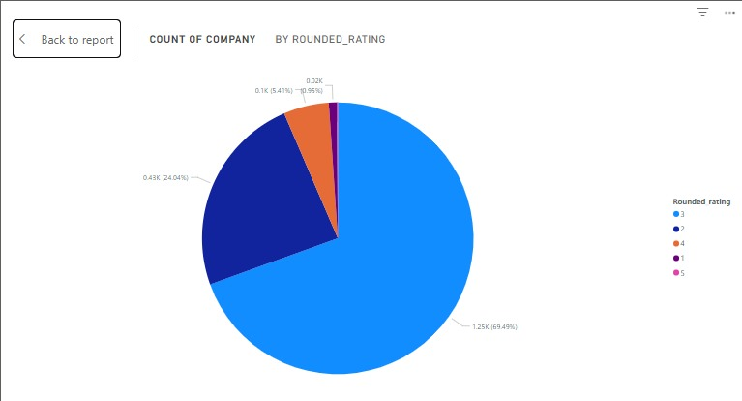

Chart

Our count of company by rounded rating pie chart showed that 69.49% of the companies were rated 3 with 24.04% rating 2 and 5.41% rating 4. This chart explains that most of the companies produced chocolate bars that were satisfactory. Such chocolate bars were not of the best quality but were praiseworthy.

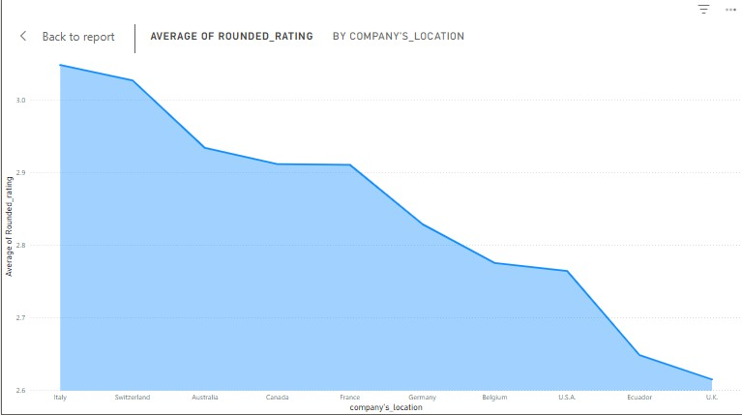

Chart

This chart talks about the average of the rounded rating by top 10 countries. With Italy emerging as first, the chart reveals that Italy was rated to be the home of top-quality chocolates, followed by Switzerland, Australia, Canada, France, Germany, Belgium, USA, Ecuador and the UK.

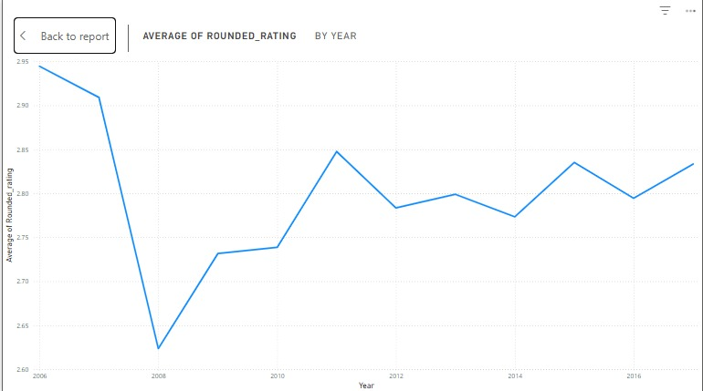

Chart

This line chart communicates the average ratings across the review years. 2006 was recorded as the year with the best average rating (2.94) with 2008 recording the lowest average rating (2.62). After the 2008 review, I noticed that the various companies tried to keep a steady average rating to make sure that good quality chocolates are being produced.

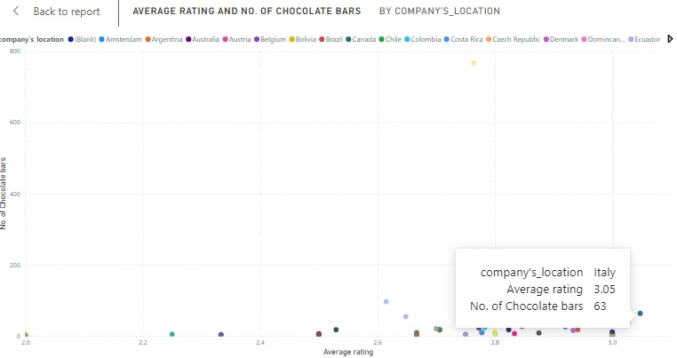

Chart

As i dug further into our investigation into the best rated chocolate bars, i found that places like Italy and Switzerland led the race, producing good quality chocolate bars as compared to the other countries.

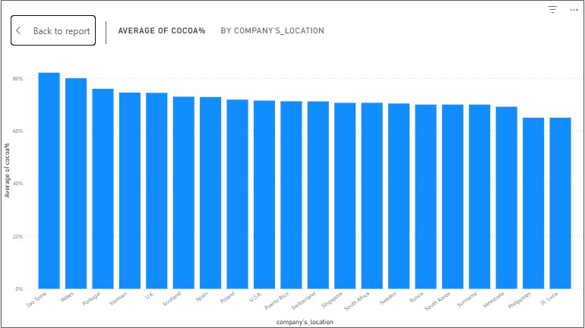

Chart

This chart depicts the average cocoa% by top 20 countries. Sao Tome averagely produced chocolates with over 80% cocoa percentage, followed by Wales and Portugal. However, from our average rating data, we realized that none of these countries were included in the top 3 rated countries with best chocolate rating.

This suggests that the cocoa% doesn’t necessarily influence the quality of a chocolate bar largely other factors also count in giving a chocolate bar its quality.

CONCLUSION

From this dataset, we can therefore conclude that despite the fact that despite the fact that cocoa% is a factor for making averagely good chocolate, it does not chiefly count in producing the best. Other factors like the bean_type comes into play. For that matter, our null hypothesis is rejected. Also, the various processes associated with the chocolate locations also count.

REFERENCE

Cidell, J. L., & Alberts, H. C. (2006). Constructing quality: The multinational histories of chocolate. *Geoforum*. https://doi.org/10.1016/j.geoforum.2006.02.006

Tan, T. Y. C., Lim, X. Y., Yeo, J. H. H., Lee, S. W. H., & Lai, N. M. (2021). The health effects of chocolate and cocoa: A systematic review. In *Nutrients*. https://doi.org/10.3390/nu13092909